Main thread body for service threads. Waits in a loop waiting for new requests to process to appear. Every time an incoming requests is added to its queue, a waitq is woken up and one of the threads will handle it.

**static int ptlrpc_main(void *arg)**

**ptlrpc_start_thread(svcpt, 0);**

**ptlrpc_server_handle_req_in(svcpt, thread);**

**task = kthread_run(ptlrpc_main, thread, "%s", thread->t_name);**

**static struct obd_ops ost_obd_ops = {**

**.o_owner = THIS_MODULE,**

**.o_setup = ost_setup,**

**.o_cleanup = ost_cleanup,**

**.o_health_check = ost_health_check,**

**};**

**static int ost_setup(struct obd_device *obd, struct lustre_cfg* lcfg)**

**struct ptlrpc_service \***

**ptlrpc_register_service(struct ptlrpc_service_conf *conf,**

**struct proc_dir_entry *proc_entry)**

**int ptlrpc_start_threads(struct ptlrpc_service *svc)**

**satic int ldlm_set(void)**

**module_init(ost_init);**

**static int __init ost_init(void)**

**satic int mds_start_ptlrpc_service(struct mds_service *m)**

**static int mgs_init0(const struct lu_env *env, struct mgs_device *mgs, struct lu_device_type *ldt, struct lustre_cfg *lcfg)**

**static int ptlrpc_server_handle_request(**

**struct ptlrpc_service_part *svcpt, struct ptlrpc_thread *thread)**

**以某种策略取得request，然后处理请求**

**static struct ptlrpc_request *ptlrpc_server_request_get(struct ptlrpc_service_part *svcpt, bool force)**

**static inline struct ptlrpc_request *ptlrpc_nrs_req_get_nolock(struct ptlrpc_service_part *svcpt, bool hp, bool force)**

**{**

**return ptlrpc_nrs_req_get_nolock0(svcpt, hp, false, force);**

**}**

**static inline struct ptlrpc_nrs_request * nrs_request_get**

**(struct ptlrpc_nrs_policy *policy, bool peek, bool force)**

**.so_req_handler= tgt_request_handle**

**svc->srv_ops.so_req_handler(request);**

**static int ptlrpc_server_request_add(structptlrpc_service_part *svcpt, struct ptlrpc_request *req)**

**参见NRS TBF阅读笔记中详细分析**

-

**static int tgt_handle_request0(struct tgt_session_info *tsi,**

**struct tgt_handler *h, struct ptlrpc_request *req)**

**rc = h->th_act(tsi);**

**target_committed_to_req(req);**

ofd_commitrw lustre/ofd

Commit bulk IO to the storage.是ofd_preprw()的伙伴函数. It finishes bulk IOrequest processing by committing buffers to the storage (WRITE) and/or freeing those buffers (read/write). See ofd_commitrw_read() and

ofd_commitrw_write() for details about each type of IO.

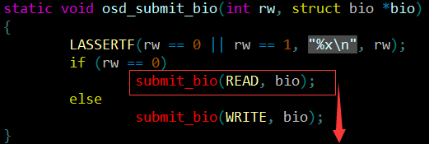

static struct tgt_handler **ofd_tgt_handlers**[] = {

TGT_OST_HDL_HP(HABEO_CORPUS| HABEO_REFERO, OST_BRW_READ, tgt_brw_read, ofd_hp_brw),

TGT_OST_HDL_HP(HABEO_CORPUS| MUTABOR, OST_BRW_WRITE, tgt_brw_write, ofd_hp_brw),

**经过这个宏ofd_hp_brw等最终会被赋值给tgt_handler的int (*th_act)(struct tgt_session_info *tsi);成员**

int tgt_brw_read(struct tgt_session_info *tsi)

进入Linux内核函数调用

osd_do_bio

lustre/osd-ldiskfs



call

osd_write_commit

lustre/osd-ldiskfs



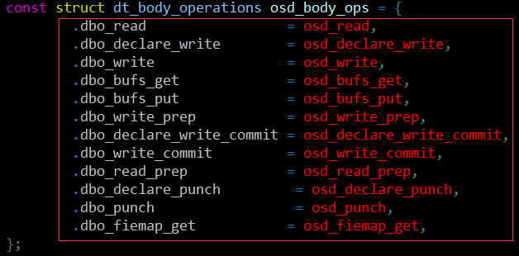

call

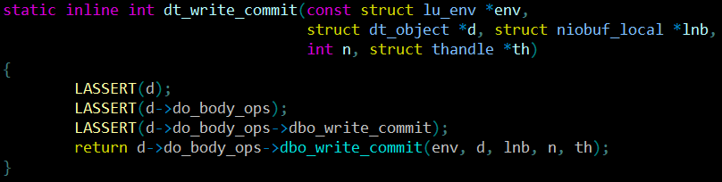

call

ofd_commitrw_read

ofd_commitrw_write

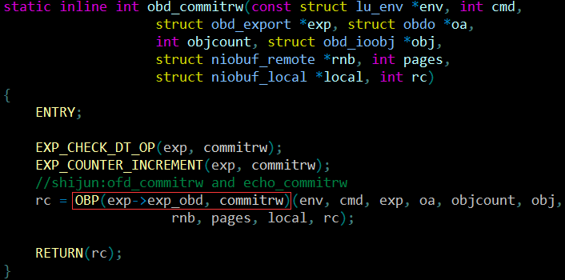

int tgt_brw_write(struct tgt_session_info *tsi)

ptlrpc_start_bulk_transfer

target_bulk_io

Lnet

两条线：一条提交到磁盘，一条开始传输（见下面分析）



ofd_tgt_handlers[]

**h获得：也即选择哪种处理**

static int ptlrpc_server_handle_request(struct ptlrpc_service_part *svcpt, struct ptlrpc_thread *thread)

{

…svc->srv_ops.so_req_handler(request);…

}

**int tgt_request_handle(struct ptlrpc_request *req)**

**static int ofd_init0(const struct lu_env *env, struct ofd_device *m,**

**struct lu_device_type *ldt, struct lustre_cfg *cfg)**

lustre/ofd/ofd_dev.c

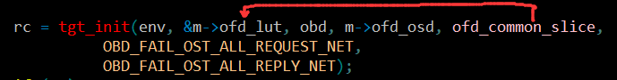

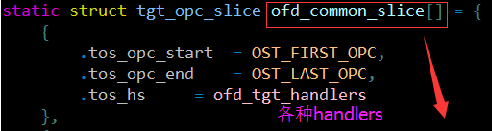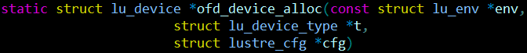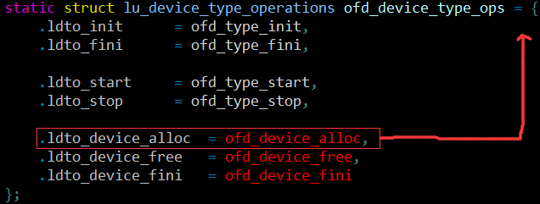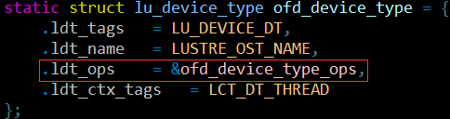

**module_init(ofd_init);**



type->typ_lu = ldt;

rc = lu_device_type_init(ldt);

static int __init mdt_init(void)

module_init(mdt_init);

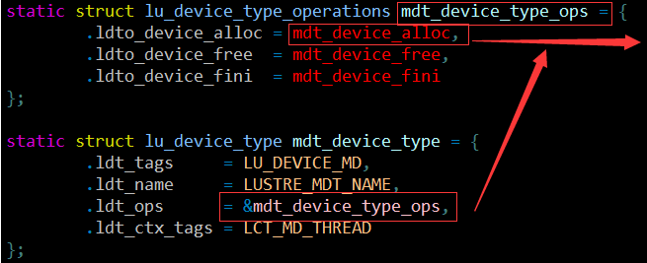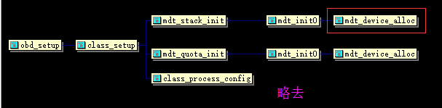

d = ldt->ldt_ops->**ldto_device_alloc**(&env, ldt, cfg);

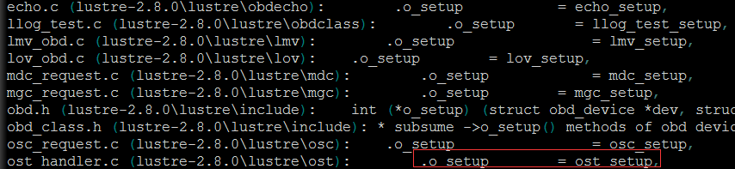

**.so_thr_init= tgt_io_thread_init,**

**.so_thr_done = tgt_io_thread_done,**

**.so_req_handler = tgt_request_handle,**

**.so_hpreq_handler = tgt_hpreq_handler,**

**.so_req_printer = target_print_req,**

**等等 类似的操作**

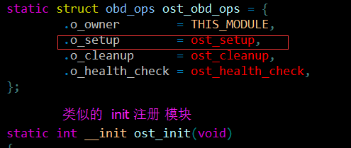

**static int tgt_handle_request0(struct tgt_session_info *tsi,**

**struct tgt_handler *h, struct ptlrpc_request *req)**

**rc = h->th_act(tsi);**

**target_committed_to_req(req);**

**h** = tgt_handler_find_check(req); 获得h

ofd_init0

rc = OBP(obd, setup)(obd, cfg);

**struct file_operations ll_file_operations_noflock = {**

**//或者是ll_file_operations_flock**

**... ...**

**.read = ll_file_read,**

**.aio_read = ll_file_aio_read,**

**.write = ll_file_write,**

**.aio_write = ll_file_aio_write,**

**... ...};**

之前的操作参见lustre文件系统注册操作

以**ll_file_write**为例

int cl_io_loop(const struct lu_env *env, struct cl_io *io)

int ptlrpcd_queue_work(void *handler));

static void osc_check_rpcs(const struct lu_env *env, struct client_obd *cli)

int osc_extent_release(const struct lu_env *env, struct osc_extent *ext)

**ll_cl_add(file, env, io);**

**rc = cl_io_loop(env, io);**

**ll_cl_remove(file, env);**

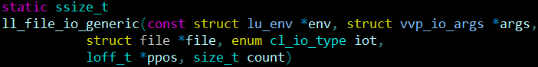

scan->cis_iop->op[io->ci_type].cio_end(env, scan);

通过结构体赋值方式

static const struct cl_io_operations osc_io_ops = {

**. . . . . .**

.cio_start = osc_io_write_start,

.cio_end = osc_io_end,

**. . . . . .**

void cl_io_end(const struct lu_env *env, struct cl_io *io)

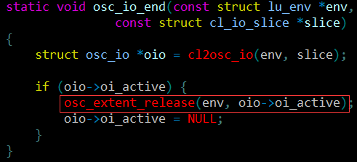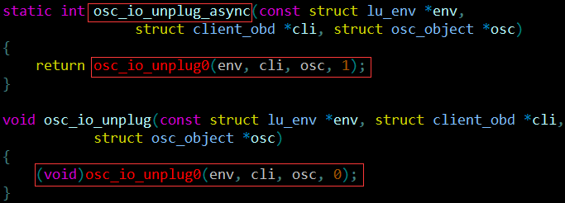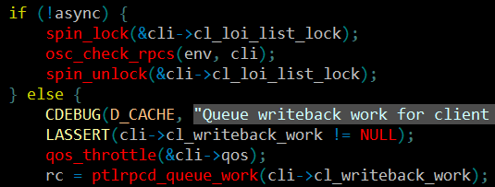

void ptlrpc_set_add_new_req**(**struct ptlrpcd_ctl **\***pc**,**

struct ptlrpc_request **\***req**)**

**{**

**list_add_tail(&req->rq_set_chain,&set->set_new_requests);**

**if** **(**count **==** 1**)** **{**

**wake_up(&set->set_waitq);**

**for** **(**i **=** 0**;** i **<** pc**->**pc_npartners**;** i**++)**

**wake_up(&pc->pc_partners[i]->pc_set->set_waitq);**

**}**

**}**

void ptlrpcd_add_req(struct ptlrpc_request *req)

req->rq_commit_cb = brw_commit;

req->rq_interpret_reply = brw_interpret;

qos_throttle(&cli->qos);

**ptlrpcd_add_req(req);**

static int osc_send_write_rpc(const struct lu_env *env,

struct client_obd *cli,struct osc_object *osc)

static int osc_send_read_rpc(const struct lu_env *env,

struct client_obd *cli,struct osc_object *osc)

pc = ptlrpcd_select_pc(req);

**ptlrpc_set_add_new_req(pc, req);**

Requests that are added to the ptlrpcd queue are sent via ptlrpcd_check->ptlrpc_check_set().

再往上参见前面的分析

static int ptlrpcd_init(void)

int ptlrpcd_start**(**struct ptlrpcd_ctl **\***pc**)**

**{. . . . . .**

task **=** kthread_run**(**ptlrpcd**,** pc**,**pc**->**pc_name**);**

**. . . . . .}**

static int ptlrpcd_check**(**struct lu_env **\***env**,** struct ptlrpcd_ctl **\***pc**)**

**{**

**......**

list_splice_init**(&**set**->**set_new_requests**,**

**&**set**->**set_requests**);**//添加 链表链接挂载

**......**

list_for_each_safe**(**pos**,** tmp**,** **&**set**->**set_requests**)** **{**

req **=** list_entry**(**pos**,** struct ptlrpc_request**,** rq_set_chain**);**

**if** **(**req**->**rq_phase **!=** RQ_PHASE_COMPLETE**)**

**break;**

list_del_init**(&**req**->**rq_set_chain**);**

req**->**rq_set **=** **NULL;**

ptlrpc_req_finished**(**req**);**

**}......**

**}**

static int ptlrpcd(void *arg){

struct ptlrpcd_ctl *pc = arg;

**. . . . . .**

l_wait_event(set->set_waitq,**ptlrpcd_check(&env, pc)**, &lwi);

**. . . . . .**

}

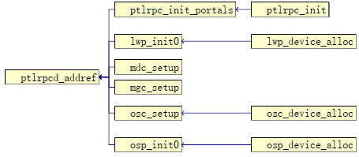

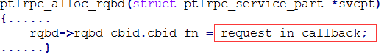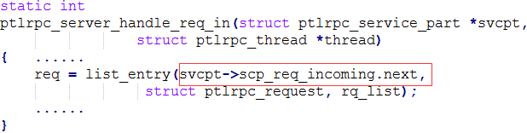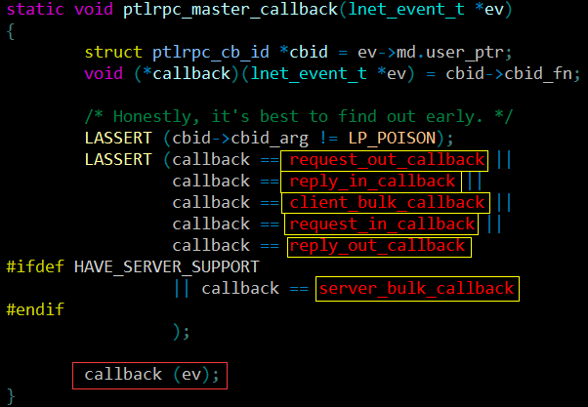

后续操作参见相关分析

类似的操作

rc = LNetEQAlloc(0, **ptlrpc_master_callback**, &ptlrpc_eq_h)

ptlrpc_master_callback

ptlrpc_ni_init

ptlrpc_init_portals

**struct ptlrpc_request**

**struct list_head set_requests**

**struct list_head cr_set_chain**

**struct ptlrpc_request_set *cr_set**

**struct ptlrpc_cli_req rq_cli**

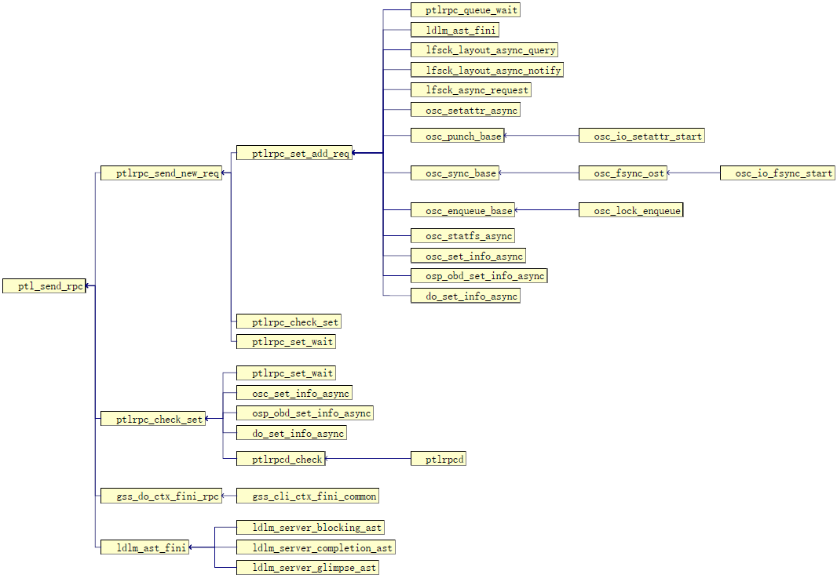

Lnet

ptlrpc_master_callback

ptlrpc_master_callback

ptlrpc_master_callback